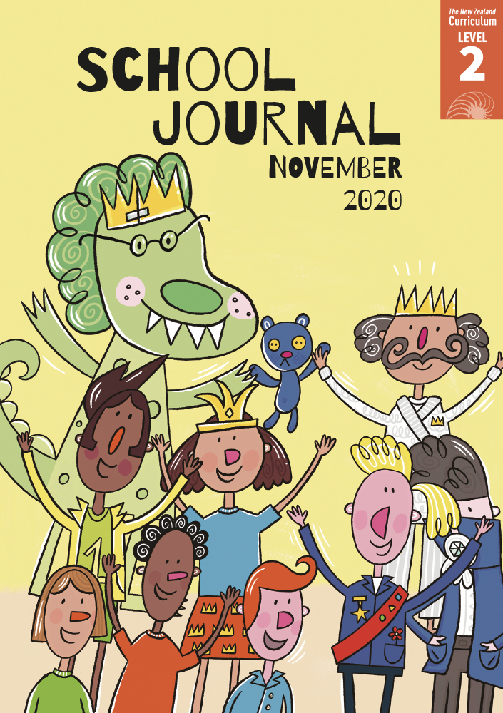

School Journal

Level 2, November 2020

**Year 4**

# The Way to Play

by Bernard Beckett

The[Learning Progression Frameworks](https://curriculumprogresstools.education.govt.nz/lpf-tool/) describe significant signposts in reading and writing   
as students develop and apply their literacy knowledge and skills with increasing expertise from school entry to the end of year 10.

## Overview

When Room 6 wins the competition to design the school’s new playground, they are really excited. However, when it comes to deciding on the design, differences of opinion emerge and the students have to work through the conflict to come up with a design that will suit them all. This story provides an opportunity to introduce and discuss the acceptance and celebration of difference.

A PDF of the text is available at [www.schooljournal.tki.org.nz](http://www.schooljournal.tki.org.nz)

## Themes

|  |  |  |  |
| --- | --- | --- | --- |
| * Problem solving | * Tolerance | * Inclusiveness |  |

## Related texts

**“Nobody Laughed”** SJ L2 Sept 2014 | **“The Best Team Ever”** SJ L2 Aug 2017 | **“The Show Went On”** SJ L2 Nov 2017 |   
**“Max and Alice”** SJ L2 Aug 2019 | **“Let’s Vote on It!”** SJ L2 May 2020 | **“Don’t Forget to Vote”** SJ L2 Nov 2020

## Strengthening reading behaviours (what to notice)

|  |  |
| --- | --- |
| Text structure and features | Requiring students to: |
| * Implied information *… voices were raised again in disagreement.  Everyone seemed to be talking at once.  Ms Mapasua just smiled*. * Noun phrases *a monkey in the treetops; own secret method* * Some incomplete sentences where one speaker interrupts another, indicated by punctuation. *“I like it because –” “No way,” Tama exclaimed.* | * use the clues in the text, for example, “Ms Mapasua just smiled”, to infer from this that the teacher knew the students would argue but that she also knew if they could see the playground from the other students’ points of view, they would be more understanding * identify the words that go together to make up the noun phrases in order to gain meaning * track the developing meaning in the conversation and make inferences about the contrasting points of view. |

|  |  |
| --- | --- |
| Vocabulary | |
| Some uncommon names | Ms Mapasua, Roland, Crystal, Tama, Mathusha |
| Other possibly challenging words  and phrases | particular, splashing, matting, sweet-smelling, layers, spinning, pretending, cargo net, skipped, struck a pose, clippings, flying fox, sketches, screwed up, compost, disgusting, interrupted, rope burn, ruins, exclaimed, excitedly, Turituri, disagreement, points of view, instruction, brilliant, flashed, method, remarkable |

|  |
| --- |
| Helpful prior knowledge (pre-reading and introducing the text) |
| * Knowledge of school playgrounds and their typical equipment, such as monkey bars, cargo net, fort, and stage, so that the reader can picture the setting * People’s views can change if they see things from another person’s perspective. * Everyone is different and has different likes and dislikes – people have their own valid reasons for their opinions. |

## Possible reading and writing purposes

* Learn how a teacher helps her students to understand each other’s point of view
* Describe what helped the students to change their minds
* Identify and discuss the author’s purpose
* Evaluate the teacher’s strategy.

See *Effective Literacy Practice in Years 1–4* for suggestions on using this text with your students ([Approaches to teaching reading](http://literacyonline.tki.org.nz/Literacy-Online/Planning-for-my-students-needs/Effective-Literacy-Practice-Years-1-4/Approaches-to-teaching-reading)) and for information about teaching comprehension strategies ([Building comprehension](http://literacyonline.tki.org.nz/Literacy-Online/Planning-for-my-students-needs/Effective-Literacy-Practice-Years-1-4/Building-comprehension) and [Text processing strategies](http://literacyonline.tki.org.nz/Literacy-Online/Planning-for-my-students-needs/Effective-Literacy-Practice-Years-1-4/Text-processing-strategies)).

## Possible curriculum contexts

This text has links to level 2 of *The New Zealand Curriculum* in: [**ENGLISH**](http://nzcurriculum.tki.org.nz/The-New-Zealand-Curriculum/English) [**HEALTH AND PHYSICAL EDUCATION**](https://nzcurriculum.tki.org.nz/The-New-Zealand-Curriculum/Health-and-physical-education)

## Understanding progress

The following aspects of progress are taken from the [Learning Progression Framework](https://curriculumprogresstools.education.govt.nz/lpf-tool/)s and relate to the specific learning tasks below. See the LPFs for more about how students develop expertise and make progress in these aspects:

* Reading for literary experience
* Making sense of text: using a processing system; using knowedge of text structure and features; vocabulary knowledge;  
  reading critically
* Using writing to think and organise for learning
* Creating texts to influence others.

## Strengthening understanding through reading and writing

**Select from the following suggestions and adapt** **them** according to your students’ strengths, needs, and experiences.   
Note: Most of these activities lend themselves to students working in pairs or small groups.

* To prompt an initial response to the story, ask the students to choose the character who is most like them. Have them partner   
  with someone who shares the same character and discuss why they chose that character. Then swap partners to discuss why they chose their character with someone who relates to a different character. Ask: *What are your favourite and least favourite spots in our school playground?* Have students discuss and share their responses.
* Support the students to summarise the story and think about the important messages. Ask questions that prompt them to say what each part is mainly about and what the author wants them to think about. For example, on pages 8 and 9: *Why did the playground need changing? What did you discover about the students’ favourite places? How did the author show you what the students thought of different spaces?* Discuss why the students had different points of view and didn’t understand that the various pieces of equipment were important to others in the class. *What did the teacher do to get the students to see the different viewpoints?*
* Have the students create a cause and effect chain to show how the storyline develops, for example: CAUSE: The students won the competition to design a playground. EFFECT: They were allowed to decide what the new playground would look like. CAUSE: The students shared what they liked and didn’t like about the existing playground. EFFECT: Nobody could agree.
* Explore the noun phrases in the text, for example, “old grass clippings”, “old wooden stage”, “monkey bars”, “own secret method”. The students could identify some from the text and then innovate and create new ones.
* The story explores why the characters liked or disliked the various playground spaces. Have the students examine how the words and phrases chosen by the author build a positive or negative picture of those spaces. They could fill in a table like the one below.

|  |  |  |
| --- | --- | --- |
| **Space in the playground** | **Positive** | **Negative** |
| The fort | enjoyed, sweet-smelling bark, warm, dry layers, lollies, special treat | No way, older kids chased me, scared |

* Discuss how the teacher got the students to listen to each others’ points of view. Have your students use the **Points of view** template at the end of this TSM to record each character’s opinion and why the characters had their particular point of view. Ask them to also record the solution. They could then add their own point of view or a different solution and explain why they think that.
* Have the students finish a sentence about the ideas of inclusiveness and listening to others, for example: “When we have different ideas, we …”; “When I think about someone else’s ideas, I …”; “To find the best solution, we …”
* Have the students:
  + write an opinion piece about a local issue, for example, the use of a local space or ways to spend fundraising money
  + prepare a survey to find out what changes students want in the playground
  + write to the board or principal (or local council) about the need for a new play area and justify why it is needed.

|  |
| --- |
| “The Way to Play” Points of view |

Opinion

Opinion

The issue

Opinion

Opinion

Opinion

Your opinion

Solution